1)

*************************

Circuit switched network consists of a set of switches connected by physical links like circuits or loop

In circuit switched network, two nodes communicate with each other over a dedicated communication path that exists between both ends until the connection is terminated. Thus, there is no delay in communication

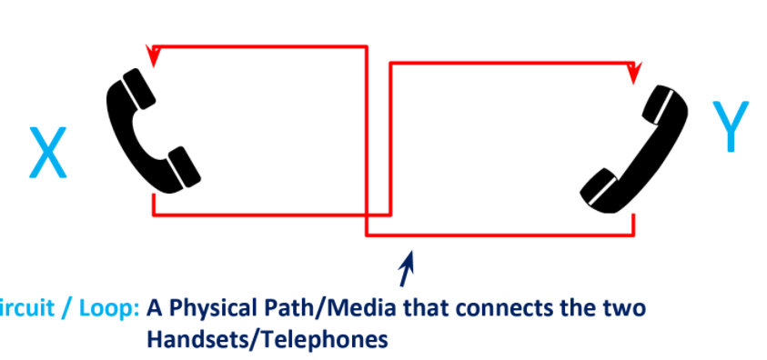

Merits: Order of delivery is identical to order of injection

Demerits: In case of communication between X and Y, when both are silent, the loop gets underutilised

This is not used in computer networks, used only in telephone networks

*********************

in message switching, it is not necessary to establish a dedicated path between transmitter and receiver.In this, each message is routed independently through the network.Each message carries a header that contains the full information about the destination.Each intermediate device receives the whole message and buffers it until there are resources available to transfer it to the next node.

If the next node does not have enough resources to accommodate large size message, the message is stored and switch waits.

For this reason a message switching is sometimes called as **Store and Forward Switching**.

Demerits :

Message switching is very slow because of store-and-forward technique.

Message switching is not recommended for real time applications like voice and video.

Messages can be of arbitrary size. hence, designing the switch is very complex

***************************************

In packet switching, messages are divided into packets of fixed or variable size.

The size of packet is decided by the network and the governing protocol.

(refer notes)

***************************************

1b)

The lowest layer of the OSI model is the physical layer. It is responsible for the actual physical connection between the devices. The physical layer contains information in the form of**bits.** It is responsible for transmitting individual bits from one node to the next.

ISSUES: unreliable bit pipe, thus there is a possibility of toggling of few bits by which output stream of bits is not identical to input stream of bits. This is a case of transmission error

2a)

421 transient negative smtp response - the server is not available because it closes the transmission channel. Your message was temporarily deferred by the recipient server. This is usually a result of too many connections in a short timeframe or too many messages.